19th and 20th Century Children’s Games in America
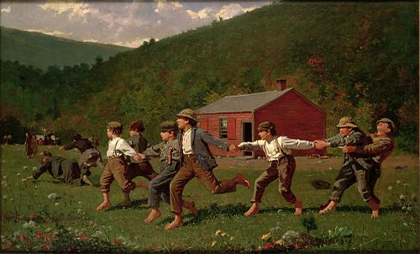

Winslow Homer
Snap the Whip,1872
Metropolitan Museum of Art, New York City, NY
https://www.metmuseum.org/art/collection/search/11140

In the 19th and 2Oth centuries children spent lots of time outdoors doing chores and playing. Looking at the painting above we can see children playing outside their schoolhouse playing ‘Snap the Whip’ during recess. What do you like to play during outdoor recess? Do you like to play games that include lots of friends or do you sometimes play with a few chosen friends? A hundred years ago, children felt the same way and played some games with the entire class and others with a couple of friends.

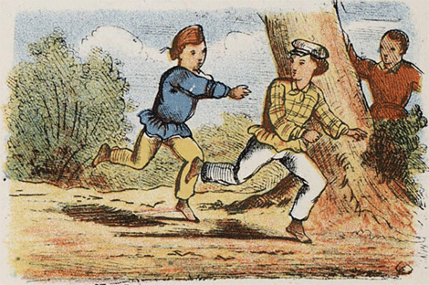
Here are a few games from the past:

TAG- Skills include running, hiding, and observation. Need two or more players. One player is chosen to be “it” first. Everyone scatters, usually in a pre-identified area, with the player chasing after them. When the “it” player tags or taps another player. The player that is tagged becomes “it” and starts to chase the others. The game continues as long as players like.
Dutch cartoon showing children playing Tag, 1860s.
https://en.wikipedia.org/wiki/Tag_(game)#:~:text=Players%20(two%20or%20more)%20decide,the%20tagged%20player%20%22it%22.

LEAPFROG- Versions of this game have been played since the 1500s. Can be played with two or more players.
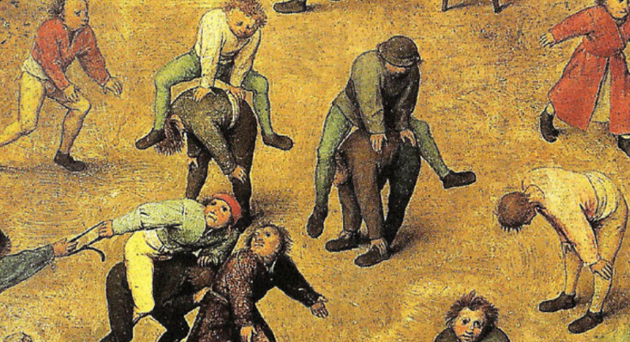
A player bends over and rests their hands on their knees. This is called giving a back. The next player places their hands on the first player’s back and jumps overtop of the first player by straddling their legs over each side of the first player’s back. The player that is leaping will then crouch and give a back to allow a third player to leap over their back. This continues until all players have leaped. If there are only two players, they take turns giving a back and leaping over one another. The game continues until the group chooses to stop.
Children’s Games
Peter Bruegel The Elder, 1560
Kunsthistorisches Museum, Vienna, Austria
BOWL TOSS- American Indian Game- Game of skill and accuracy. Two or more players. Begin by marking a large circle that is about 18 inches in diameter on the ground with twigs, string, or a hoop. Make a throwing line about 12 feet from the circle. Each player needs three pine cones.
Players stand behind the throwing line. One at a time, each player throws a pinecone using an underhanded toss. The goal is to land each pinecone inside the circle. One point is given for cones that land in the circle but then fall out. Three points are given for each cone that remains in the circle. As players become more skilled the circle can be moved farther away. After throwing each of their three pinecones, another player steps forward and takes their turn tossing the cones.
https://www.mackinacparks.com/wp-content/uploads/2014/01/Games.pdf

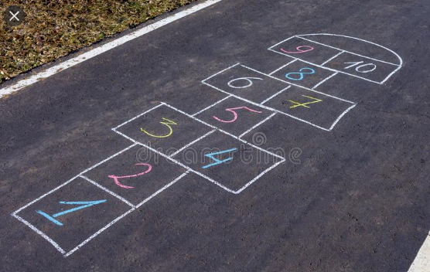
HOPSCOTCH-A game of balance and skill. You will need chalk (or masking tape if playing indoors), and a marker which can be a button, pebble, bottle cap or small plastic toy.
Activity: With chalk draw your hopscotch board on the sidewalk or playground. See the illustration at the side. Mark a number 1-10 in order in each of the squares. Choose something as your marker like a pebble or coin that will lay flat. The player tosses their marker to the square with a 1. Then the player hops over that square, up the board and back again, stopping in square two. They bend over and pick up their marker, stand again and hop over square 1 to the beginning spot. The player may not touch any lines and must hop in each square. Single squares must be hopped on one foot, except for the first single square, where either foot may be used. Side-by-side squares are straddled, with the left foot landing in the left square, and the right foot landing in the right square.
If the player completes their turn properly, the player continues the turn by tossing the marker into square number two, and repeating the pattern.
If, while hopping through the court in either direction, the player steps on a line, misses a square, or loses balance, the turn ends. Players begin their turns where they last left off. The first player to complete one course for every numbered square on the court wins the game.
https://www.youtube.com/watch?v=aUi0V6_ROWA-Rules of hopscotch are explained by two children
**Be creative and think of new ways to play this game. Perhaps each player is timed, or toss the marker in any order. Keep track of the squares the player has completed by drawing a small picture in the square or writing their initials. Draw the hopscotch board using different shapes and colors. https://www.parents.com/fun/activities/hopscotch/

COME WITH ME- A game of coordination and speed. Activity: A group of children stand in a circle. One person remains outside of the circle and he/she is “it.” That person will tap someone on the shoulder and shout, "Come with me!" The two run in opposite directions around the circle. When they meet, they clasp hands, swung their arms in the air once and raced for the empty spot where the tapped person had been standing. The one who gets there first stays there. The other person becomes "it" and continues the game.
https://ourpastimes.com/kid-games-in-the-early-1900s-13583112.html- Rules of this game

SNAP THE WHIP-also called Crack the Whip- A game of physical coordination. Five or more players. No extra tools are needed to play this game.
All players hold hands securely. One player is chosen to be the “head” of the whip. The head of the whip runs around in random directions. The rest of the players, or the “tail” of the whip are forced to move in a similar direction. Those at the end of the tail will be whipped around with more force. The longer the tail, the greater the force on that player. As players fall off of the whip, they can join the again but must go to the end of the tail. Players may be able to move up the whip line to gain a more secure position. Players might also be unable to join hands again once they have fallen off due to the speed of the whip. There is no winning objective. Just have fun but be safe!
**This game is illustrated in Winslow Homer’s Snap the Whip oil painting, 1872. He imagined a scene from his childhood school.
https://en.wikipedia.org/wiki/Crack_the_Whip

HIDE AND SEEK- Game of listening and observation. Two players or more. Before the start of the game the players will agree on the game space, for instance the game hiding spaces might be limited to one or two yards, outside only.
One player starts by being the seeker. The seeker closes their eyes and counts to 20 aloud so the players can hear. The other players hide silently. When the seeker gets to 20, they announce, “Ready or not, here I come!” and they begin to look around to find each of the hiding players. A new game begins after all the hiders have been found.

JUMP ROPE-Often times children would sing a song or rhyme while jumping rope. The crowd watching or waiting their turn to jump might sing along with the jumper.
Here is a common rhyme:

Down in the valley
Where the green grass grows
There sat (say a name of someone you know)
As a sweet as a rose
She sang, she sang,
She sang so sweet
Along came (say another name)
And kissed her on the cheek
How many kisses did he/she giver her
That week?
5, 10, 15, 20, 25, 30……

I am a little Dutch girl,
As pretty as can be, be, be,
And all the boys around my block
Are crazy over me, me, me,
My mother gave me peaches,
My father gave me pears,
My boyfriend kissed me on the cheek,
And fell right down the stairs.

Burns, B and Burns, R. (1983) A Child’s Folklife Traditions, Worthington Arts Council

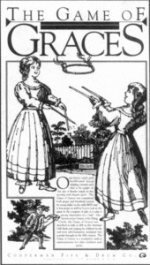
GAME OF GRACES- Two players. Game of skill, grace and balance. To play the game a hoop about 10 inches in diameter is needed plus each player needs two smooth sticks or dowel rods about 12 inches long. The goal is to catch a hoop with two dowels or sticks that is tossed from another player with two dowels or sticks. Originally the game was played by girls and thought to teach how to move gracefully.
https://gazette665.com/2018/02/28/childrens-games-mid-19th-century-style/

CHARADES- A game of observation, listening, silent acting, and critical thinking. Two or more players.
In the early 1800s this was a word game where one person would describe a word through a pun or a poem. The other person had to guess the word. By the mid-1800s it became more of a silent acting game. Ahead of time, write the title of a book, movie, activity, place, or event on a piece of paper. Here is a charade idea generator: http://www.getcharadesideas.com/charades-for-kids/One title per paper. Fold the papers so no one can see the written words. The first player chooses a paper. Then without using words, shows how many words are in the title by holding up that many fingers. The player explains if it is a book title by holding hands like an open book. If it is a song title, pretend to sing. If it is a movie, hold one hand up to the face to pretend they are looking through a camera and crank the old movie camera. If it is an activity, jump up and down.
The player then act out or pantomime the word or phrase he's chosen to the other players. To pantomime a word that rhymes with the word you want players to guess, first tug on your ear to say "sounds like."
The first person to guess the word or phrase gets a point. You can play in teams if there are more than two players. Each team takes a turn, acting out the words for their teammates. Keep track of the points earned by each player or team. The one with the most points at the end of the game wins.
https://www.familyeducation.com/fun/best-toys/top-12-new-outdoor-toys-for-summer
https://gazette665.com/2018/02/28/childrens-games-mid-19th-century-style/
https://www.mackinacparks.com/wp-content/uploads/2014/01/Games.pdf

